ACTRI Data Extraction Concierge Service (DECS)

Scope of Work

Revision Date:

# Request Details

|  |  |
| --- | --- |
| DECS Request #: | DECS-2109 |
| Principal Investigator (Name, E-mail): | Elsie Ross e5ross@health.ucsd.edu |
| Requester (Name, E-mail): | Elsie Ross e5ross@health.ucsd.edu |
| IRB #: | 808866 |
| IRB Expires: | None |
| Study Name: | The application of machine learning and computer vision to optimize |
| Data Set Name: | UCSD EHR Data |
| Request Type: | Clarity |
| Due Date: | 11/16/2023 |
| Prior Request #: | None |
| External Entity: |  |
| External SQL Code? |  |
| Data Source: |  |
| Individuals needing VRD access: *(in addition to PI/requester; must be listed on IRB)* | Elsie Ross |
| Special Instructions: | Accession numbers are ok instead of Images then send PI to Radiology team such as Michael Crook to gather Images. |

# Billing Information

|  |  |
| --- | --- |
| OFC Project Number: | 2032517 |
| OFC Task Number: | 1 |
| OFC Funding Source Number: | 15013 |
| ACTRI Voucher ID: | none |
| ACTRI Voucher Expiry Date: | none |
| ACTRI Voucher Value: | none |
| ACTRI Voucher Funds Available: | none |
| Voucher Shared with other requests? (Provide Details) | none |

# Criteria

|  |  |
| --- | --- |
| Extraction Date Range: | 1/01/2010 – 12/01/23 |
| Criteria Date Range (if different): |  |
| Requester to Provide Patient List: |  |
| Living requirement? | No |
| Min/max Patient age: | Min age 18 yo, no max |
| Age at: | surgery |
| Include In-custody Patients: | Yes |

## Inclusion Criteria

The conditions required to consider a patient for inclusion (e.g., procedures, medications, diagnoses). By default, ALL conditions must be met for inclusion.

MUST HAVE THESE:

The following diagnosis codes: ICD9: 440.2*, 440.3*, 440.8,

440.4, 443.9 ICD-10:

I70.2*,I70.3*,I70.4*,I70.5*,I70.6*,I70.7*,I70.8,I70.92,I73.9

OR IN (

With ANY the following procedures:

ICD-9-CM: 39.50, 39.90, 38.18 ICD-10-PCS: 047C3*, 047D3*, 047H3*,

047J3*, 047K3*, 047L3*, 047M3*, 047N3*, 047P3*, 047Q3*, 047R3*, 047S3*, 047T3*,

047U3*, 047V3*, 047W3*, 047Y3*, 04C00ZZ, 04C03ZZ, 04CC0Z*, 04CC3Z*, 04CC4Z*,

04CD*, 04CH*, 04CJ*, 04CK*, 04CK*, 04CL*, 04CM*, 04CN*, 04CP*, 04CQ*, 04CR*,

04CS*, 04CT*, 04CU*, 04CV*, 04CY*, 04100J7, 04100J8, 04100JF, 04100JG, 04100JH,

04100JJ, 04100JK, 041C0JD, 041C0JH, 041D0JF, 041D0JJ, 041H0JH, 041H0KJ,

041H4JH, 041J0JJ, 041J4JJ, 041K0J*, 041K0Z*, 041L09*, 041L0J*, 041L0K*,

041L0Z*, 041M*, 041N*, 041S0JQ, 041U0AP

INCLUDE THE WHOLE LIST:

* 1 DIGIT DIFF

** 2 DIGIT DIFF

With ANY the following procedures:

CPT code: 37205, 37206, 37207, 37208,

37236, 37237, 37184, 37185, 37186, 35302, 35303, 35304, 35305, 35306, 35331,

35351, 35355, 35361, 35363, 35371, 35372, 35381, 35452, 35454, 35456, 35459,

35470, 35472, 35473, 35474, 35483, 35492, 35493, 35495, 35521, 35533, 35537,

35538, 35539, 35540, 35556, 35558, 35563, 35565, 35566, 35571, 35583, 35585,

35587, 35621, 35623, 35637, 35638, 35646, 35647, 35654, 35656, 35661, 35663,

35665, 35666, 35671, 35700, 35876, 35879, 35881, 35883, 35884, 37184, 37185,

37186, 37205, 37206, 37207, 37208, 0236T, 0237T, 0238T, 37225, 37224, 37227,

37226, 37222, 37223, 37220, 37221, 37229, 37228, 37231, 37230, 37233, 37232,

37235, 37234, 35548

)

## Exclusion Criteria

The conditions for excluding a patient (e.g., pregnant, medical history, conflicting diagnoses). By default, ANY condition must be met for exclusion.

## Anyone with any of these codes in their record: ICD-9:

## 736.3*, 736.4*, 736.5, 736.6, 736.7*, 736.8*, 736.9, 735.*, 754.3*, 754.4*,

## 754.5*, 754.6*, 754.7*, 755.02, 755.13, 755.14, 755.3, 755.4, 755.6*, 755.8,

## 759.7, 759.89, 895.*, 896.*, 897.*, 820.*, 821.*, 822.*, 823.*, 824.*, 825.*,

## 826.*, 827.*, 828.*, 829.*, 835.*, 836.*, 837.*, 838.*, 904.*, 928.*, 929.*,

## 959.6, 959.7, 996.4*, 996.66, 996.67, 996.77, 996.78 ICD-10: M21.05*, M21.06*,

## M21.07*, M21.15*, M21.16*, M21.17*, M21.7*, M21.869, M21.6X*, M21.85*, M21.86*,

## M21.95*, M21.96*, M20.1*, M20.2*, M20.3*, M20.*, M20.5*, M20.6*, Q65.**,

## Q68.1*, Q68.2*, Q68.3*, Q68.4*, Q68.5*, Q66.3*, Q66.4*, Q66.5*, Q66.6*, Q66.7*,

## Q66.8*, Q69.2*, Q70.2*, Q70.3*, Q72.**, Q74.8, Q74.9, Q89.7, E78.71, E78.72,

## Q87.2, Q87.3, Q87.5, Q87.81, Q87.82, Q87.89, Q89.8, S72.**, S82.**, S92.**,

## T14.8*, M24.35*, M24.36*, M24.37*, S83.**, S93.**, S75.**, S79.**, S99.**,

## S77.**, S89.**, T84.**

## INCLUDE THE WHOLE LIST:

## * 1 DIGIT DIFF

## ** 2 DIGIT DIFF

## Notes

Screenshot for reference of the Accession number see “Results” section grey bar below.

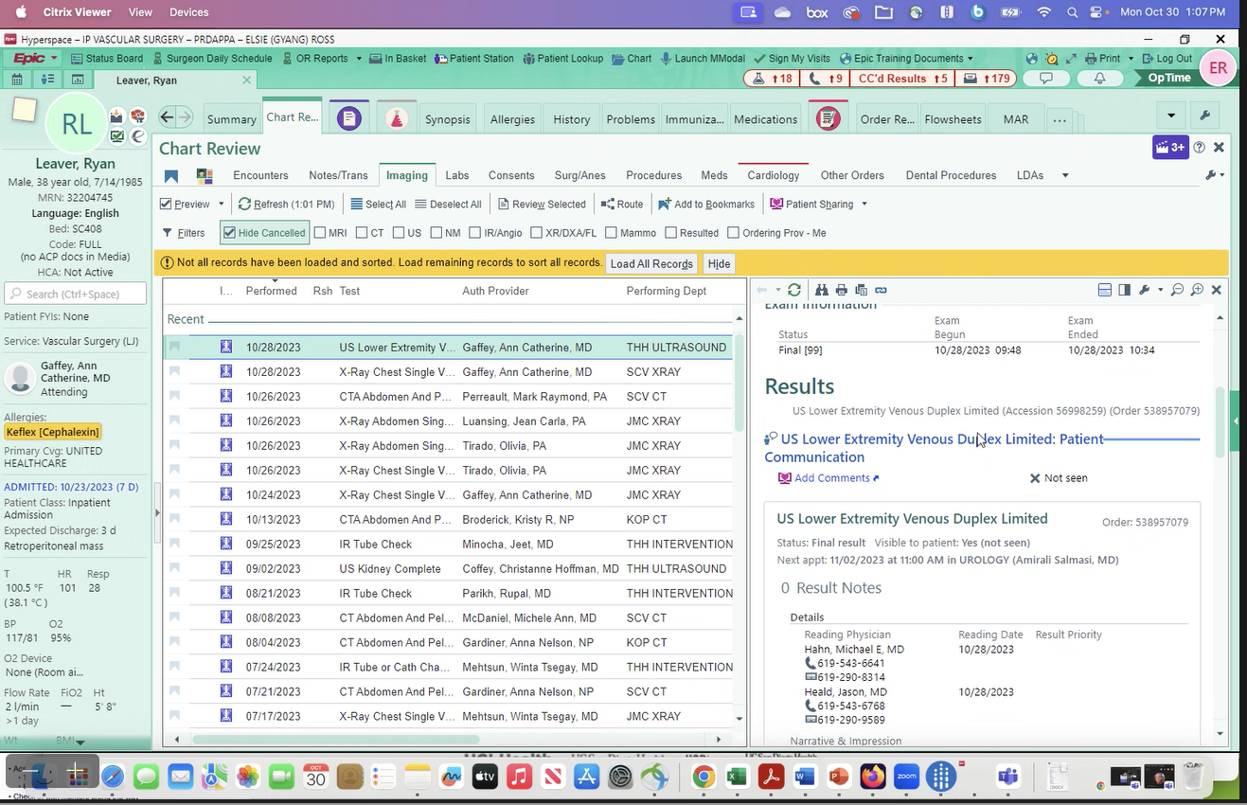

# Extract

Output Format:

Destination:

## Variables

The specific data elements to pull, in as much detail as possible.

Most items will be readings/values as of the index date, unless otherwise specified.

Diagnoses should check both the problem list and encounter diagnoses.

### Patient/Cost Data

FYI – “surgery” refers to invasive angiography procedures

* MRN,
* date of surgery,
* accession numbers for invasive angiograms,
* ~~invasive angiogram images~~ (Dr. Ross Images can be gathered by the Radiology Team such as Michael Crook)
* accession number for non-invasive CT (Dr. Ross can we get an example of this from Hyperspace to verify?) - Attached
* CT angiograms completed 3-6 months before or after date of surgery, (Dr. Ross can we get an example of this from Hyperspace to verify?) – This is the same request as above, just time specified. CT angiogram up to 6 months before and after date of invasive angiography
* ~~CT angiogram images,~~ (Dr. Ross Images can be gathered by the Radiology Team such as Michael Crook)
* history and physical raw notes from 30 days prior to day of surgery or on the day of surgery,
* operative report (TROY - NOTES) related to day of surgery,
* (TROY - IN THE IMAGING TAB OF EPIC) vascular ultrasound report 30 days before surgery (or ankle brachial indices) or on day of surgery ,
* all vascular ultrasound reports after the day of surgery (or ankle brachial indices) for up to 1 year, (Dr. Ross can we get an example of this from Hyperspace to verify?) – Attached
* procedure codes after date of surgery up to 1 year (Dr. Ross could you clarify? Typically, we pull all procedure codes associated to a visit over a specified date period [e.g. 01/01/2023 – 01/28/2023] and criteria) – this is to evaluate if patient had any repeat vascular procedures after their index case. So if date of surgery was 12/6/2023, we want all CPT codes from 12/7/23-12/6/24

# Estimates

|  |  |
| --- | --- |
| Estimated Complexity: | 4 |
| Estimated Billable Time (Hours): | 7-10 |
| Recharge Billing Rate (per Hour): | $128.00 |
| Estimated Cost: | $1280 |
| Estimated Completion Date: | 11/14/2023 |

The above costs and times are based on our best-effort estimates, but the final costs may be higher (or lower).

# Revision History

|  |  |  |
| --- | --- | --- |
| Date | Initials | Details |
| 10/31/2023 | TM | Initial draft |
|  |  |  |
|  |  |  |

# ACTRI DECS Policies

These are the ACTRI DECS Policies that will apply to this request.

## Changes

Once approved by the requester/PI, this Scope of Work (SoW) defines the exact request to be implemented. At the DECS management team’s sole discretion, minor changes may be accepted post-approval, such as an additional diagnosis code or simple field addition.

Significant changes require written justification by the requester, for review and approval by the DECS management. Approved changes will be documented with addendum to original SOW, to detail the changes and affects to timeline, priorities, and completion date. Modifications to original SOW are subject to additional time/costs involved.

## Review

Once the data set is released to the requester/PI, the requester/PI will have **21 days** to review the data set and raise any questions about that data (the “Review Period”). After the Review Period, if no questions or issues are raised, the data set will be deemed accepted by the requester/PI. The DECS ticket will be closed – any queries after such time will generate a new DECS ticket, and will be treated as a new work order and SoW. This allows the DECS team to properly process and allocate resources to new requests and prevents disruption to existing requests already in progress.

If the requester/PI has issues with the data set, they need to provide a detailed report of the potential error, to allow the analyst to investigate.

Any issues raised after the review period will be considered under the Change request policy, subject to new SOW and associated costs.

## Charges

All time the DECS team spends on this request is considered billable, with the following standard exceptions:

1. Any pre-request consultation meetings.
2. The initial consult and work to finalize this SoW document.
3. Investigating Review Period queries.
4. E-mails with the requester/PI.

Other activities may also be non-billable, at the discretion of the DECS team.

Non-billable time is considered paid for by the ACTRI Grant, which is why all DECS requests require quoting the ACTRI Grant in publications.

DECS recharges are submitted monthly for billable work performed that month.

## Cite the Grant

Use of the data from this request requires that you cite the **UCSD ACTRI CTSA Grant** in all publications:

"The project described was partially supported by the National Institutes of Health**, Grant UL1TR001442 of CTSA funding.** The content is solely the responsibility of the authors and does not necessarily represent the official views of the NIH."

## Patient Filtering

Per UCSD/ACTRI policy, all patients returned in DECS requests must either be listed in the Epic Research-Eligible Registry, or explicitly consented on the study.

The Research-Eligible Registry currently excludes specific classes of UCSD patients, including VIPs, staff, faculty and students. We also exclude patients who explicitly requested not to be included in research. This Registry will evolve over time to include individual MyChart opt-in/out for research.

For recruitment and contact requests, we also remove patients who stated they do not wish to be contacted for research (the “No-Contact” list). If any patient we provide indicates that they do not want to be contacted for research please notify the DECS team so we can add them to the No-Contact list.

## Decedent Data

If your request requires only living patients (e.g., for recruitment), or needs to know if/when a patient died, we use Epic data in combination with the California Death Registry to determine a patient’s status. We cannot guarantee the completeness or accuracy of decedent data.

## Virtual Research Desktop (VRD)

Standard DECS procedure is to release data to the study via VRD, a highly-secure AWS-based virtual computer, providing your team with access to the data and a large suite of tools for analyzing and working with that data. The VRD environment is compliant with UCSD Research data security best practices, and should satisfy your IRB data security requirements.

Access to the VRD is automatically granted to the requestor and PI, but by default a PI VRD account is only created on request (as we found many PI’s did not use their account). Initial access will also be granted to individuals listed in this Scope of Work, but per UCSD policy anyone with VRD access must be listed on the IRB. Access for additional users may be requested through ACTRI Application Support.

## UCSD Policy Documents

The following UCSD policy documents apply to all DECS requests and their data:

* UCSDHP 9 - *Research: Utilization of Protected Health Information (PHI)* - <https://pulse.ucsd.edu/policies/UCSDHPs/MCPolicy/9-0.pdf>
* UCSDHP 10 - *Protected Health Information (PHI): De-identification, Limited Data Set (LDS) and Data Use Agreement (DUA)* - <https://pulse.ucsd.edu/policies/UCSDHPs/MCPolicy/10-0.pdf>
* Additional UCSD/UC policies may apply.

The DECS team members are considered “data stewards” as defined in these policies.